COLLEGE PLACEMENT CELL PORTAL
A MINI-PROJECT REPORT
Submitted by

SANTHOSH G 240701473
ROHITH D 240701435

in partial fulfillment of the award of the degree

of

BACHELOR OF ENGINEERING
IN
COMPUTER SCIENCE AND ENGINEERING
RAJALAKSHMI ENGINEERING COLLEGE, CHENNAI
An Autonomous Institute
CHENNAI
NOVEMBER 2025

BONAFIDE CERTIFICATE
Certified that this project “COLLEGE PLACEMENT CELL PORTAL” is the bonafide work of “SANTHOSH G, ROHITH D” who carried out the project work under my supervision.

SIGNATURE
MRS SATHIYA VATHI
ASSISTANT PROFESSOR SG
Dept. of Computer Science and Eng,
Rajalakshmi Engineering College
Chennai

This mini project report is submitted for the viva voce examination to be held on __________

INTERNAL EXAMINER EXTERNAL EXAMINER
ABSTRACT

This project aims to streamline the campus placement process by developing a desktop-based portal using Java Swing and Oracle SQL. It enables student registration, company listings, application tracking, and placement analytics. The system provides a user-friendly interface for students and administrators, with features like eligibility filtering, resume uploads, and placement reports. This solution enhances efficiency, reduces manual errors, and supports data-driven decision-making for placement coordinators.

ACKNOWLEDGEMENT

We express our sincere thanks to our beloved and honorable chairman MR. S. MEGANATHAN and the chairperson DR. M.THANGAM MEGANATHAN for their timely support and encouragement.
We are greatly indebted to our respected and honorable principal
Dr. S.N. MURUGESAN for his able support and guidance.
No words of gratitude will suffice for the unquestioning support extended to us by our Head Of The Department Dr. E.M. MALATHY and our Deputy Head Of The Department Dr. J. MANORANJINI for being ever supporting force during our project work
We also extend our sincere and hearty thanks to our internal guide MRS SATHIYA VATHI , for her valuable guidance and motivation during the completion of this project.
Our sincere thanks to our family members, friends and other staff members of computer science engineering.
1. SANTHOSH G
2. ROHITH D

TABLE OF CONTENTS

CHAPTER NO. TITLE PAGE NO
ABSTRACT iv

1 INTRODUCTION 7
1.1 INTRODUCTION
1.2 SCOPE OF THE WORK
1.3 PROBLEM STATEMENT
1.4 AIM AND OBJECTIVES OF THE PROJECT

2 SYSTEM SPECIFICATIONS 9
2.1 HARDWARE SPECIFICATIONS
2.2 SOFTWARE SPECIFICATIONS

3 MODULE DESCRIPTION 10

4 CODING 11

5 SCREENSHOTS 12

6 CONCLUSION AND FUTURE ENHANCEMENT 15

7 REFERENCES 17

LIST of figures
FIGURE NO. | TITLE | PAGE NO.
5.1 | LOGIN PAGE | 15
5.2 | STUDENT REGISTRATION | 15
5.3 | COMPANY REGISTRATION | 16
5.4 | ELIGIBILITY FILTER | 16
5.5 | PLACEMENT REPORT | 17

CHAPTER 1
INTRODUCTION
  - INTRODUCTION
The College Placement Cell Portal aims to digitize the placement workflow in engineering colleges. Traditionally, placement activities are managed manually, leading to inefficiencies and data inconsistencies. This project provides a structured platform for students and administrators to interact with placement data. It ensures that students can easily access company details, apply for jobs, and track their application status.
  - SCOPE OF THE WORK
The scope of this project includes student registration, company onboarding, application tracking, and placement analytics. It is designed to serve both students and administrators with role-specific functionalities. The portal supports eligibility filtering based on CGPA and department, making it easier to match students with suitable companies. It also includes resume upload and report generation features for enhanced usability.
  - PROBLEM STATEMENT
Manual placement tracking often leads to errors, delays, and lack of transparency. Students may miss opportunities due to poor communication or eligibility mismatches. Administrators struggle to maintain accurate records and generate reports efficiently. This project addresses these issues by providing a centralized, automated system that improves data accuracy and user experience.

1.4 AIM AND OBJECTIVES OF THE PROJECT
The main aim of this project is to develop a user-friendly desktop portal that simplifies the placement process. Objectives include enabling student registration, company listing, application submission, and eligibility filtering. The system also aims to provide real-time analytics and exportable reports for administrative use. Ultimately, it seeks to enhance placement outcomes and reduce manual workload.

CHAPTER 2
SYSTEM SPECIFICATIONS
2.1 HARDWARE SPECIFICATIONS
Processor | : | Intel i5
Memory Size | : | 4GB (Minimum)
HDD | : | 1 TB (Minimum)

2.2 SOFTWARE SPECIFICATIONS
Operating System | : | WINDOWS 10
Front – End | : | Java Swing
Back - End | : | Oracle SQL
Language | : | Java SE Development Kit (JDK) 17+

CHAPTER 3
MODULE DESCRIPTION
This application consists of two modules. When the program runs, it will ask for a confirmation to the login window. The person who interacts can login as an Administrator or as a Student. The description of the modules are as follows:
3.1 STUDENT MODULE
Students can register, view company listings, and apply for eligible jobs. The system checks CGPA and department before allowing applications. Students can also upload their resumes and view placement reports. The interface is designed to be intuitive and responsive.
3.2 ADMIN MODULE
Administrators can add companies, view student applications, and generate placement analytics. They can filter students based on eligibility and export reports in PDF or Excel formats. The admin dashboard uses tabbed navigation for easy access to different modules.
3.3 ELIGIBILITY FILTER
This module checks if a student meets the CGPA and department criteria for a company. It uses SQL queries with INSTR() and comparison operators to match student profiles with company requirements. The system displays a list of eligible companies and highlights the highest offer.
3.4 PLACEMENT REPORT
The report module shows total placed students, highest package offered, and department-wise placement stats. It uses aggregate SQL functions like COUNT, MAX, and AVG. Reports can be exported for documentation and analysis.
CHAPTER 4
SAMPLE CODING
DBCONNECTION CODE:
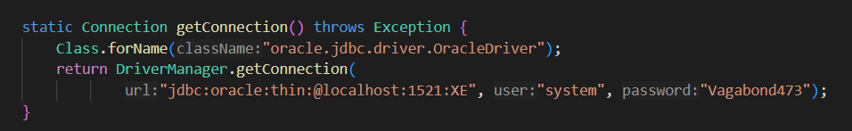
MAIN PORTAL CODE:
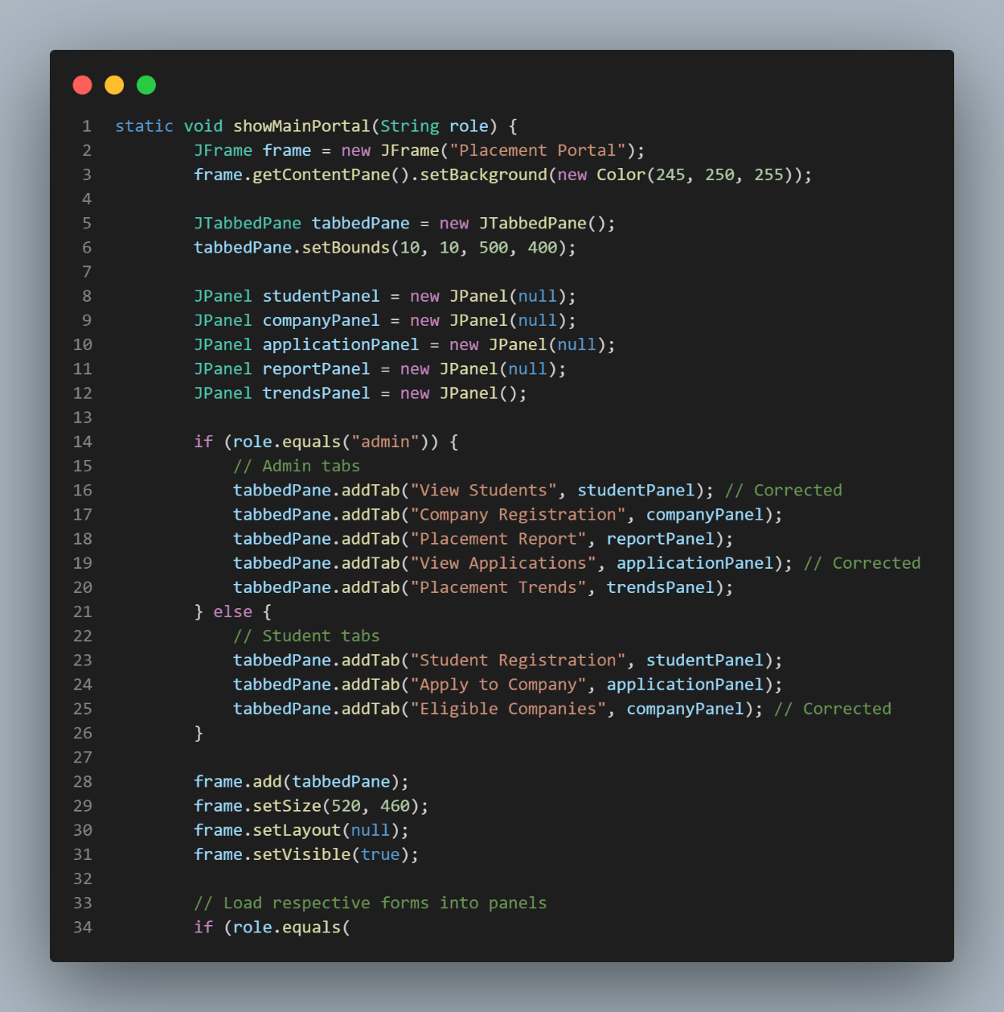
CHAPTER 5
SCREEN SHOTS
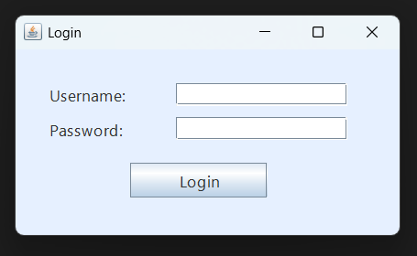
Fig 5.1 Login page
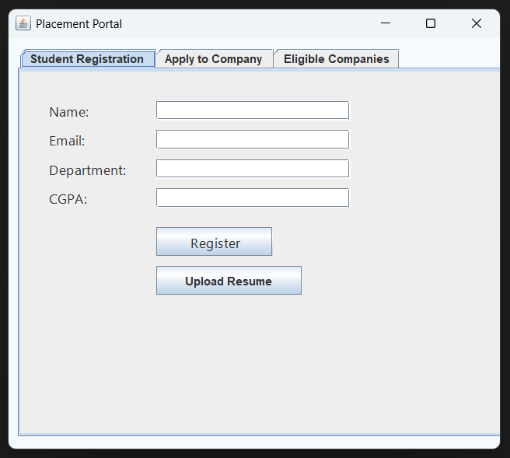
Fig 5.2 Student Registration Form
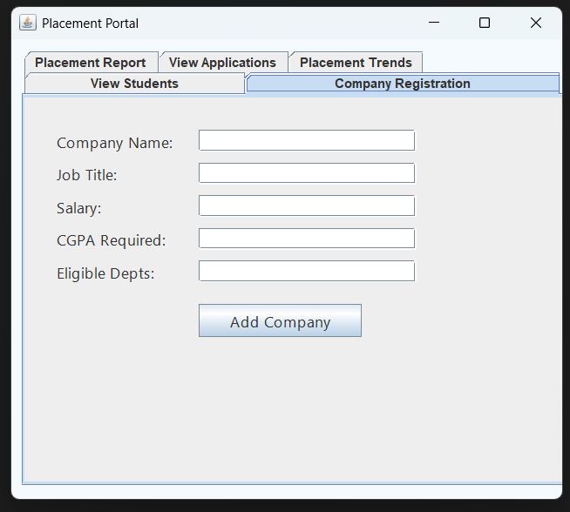
Fig 5.3 Company Registration Form
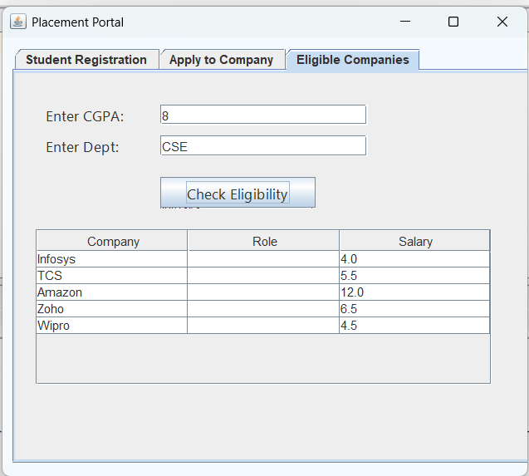
Fig 5.4 Eligibility Filter Output
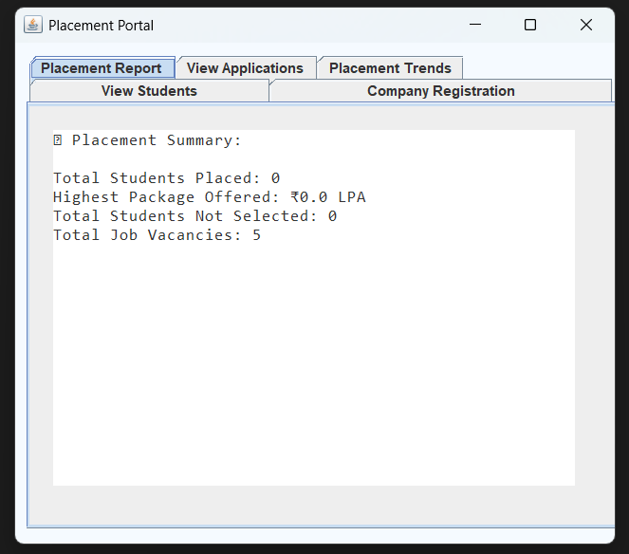
Fig 5.5 Placement Report Dashboard

CHAPTER 6
CONCLUSION AND FUTURE ENHANCEMENT
The College Placement Cell Portal successfully automates key placement activities and improves data management. It provides a clean interface for students and powerful tools for administrators.
In the future, the system can be extended to support
6.1 Web-Based Deployment
One of the most promising enhancements is migrating the desktop application to a web-based platform. This would allow students and administrators to access the portal from any device with internet connectivity, removing the dependency on local installations. Technologies such as HTML5, CSS3, JavaScript (React or Angular), and backend frameworks like Spring Boot or Node.js can be used to build a responsive and secure web version. This transition would also enable cloud-based hosting and centralized data management.
6.2 Email and SMS Notifications
Integrating automated notifications would improve communication between students and the placement cell. For example, students could receive alerts when new companies are added, when they are shortlisted, or when interview dates are scheduled. This can be achieved using SMTP protocols for email and third-party APIs like Twilio for SMS. Notifications would reduce manual follow-ups and ensure timely updates for all stakeholders.

6.3 Resume Analyzer and Matching Engine
A future version of the portal could include a resume analyzer that scans uploaded resumes and suggests suitable companies based on skills, experience, and academic background. This feature would use natural language processing (NLP) and machine learning algorithms to extract keywords and match them with company requirements. It would help students discover opportunities they might otherwise overlook and assist recruiters in identifying top candidates.
6.4 Mobile App Integration
Developing a companion mobile application would enhance accessibility and convenience. Students could apply for jobs, upload resumes, and receive notifications directly from their smartphones. The mobile app could be built using Flutter or React Native for cross-platform compatibility. Features like biometric login and push notifications would further improve user experience and security.
6.5 Data Visualization and Dashboards
To support decision-making, the portal could include interactive dashboards for placement statistics. Using libraries like JFreeChart or integrating with BI tools such as Tableau or Power BI, administrators could visualize trends in student applications, placement rates, and company participation. These insights would help improve placement strategies and identify areas for academic improvement.

REFERENCES
[1] Oracle Corporation, “Oracle Database Documentation,” [Online]. Available: https://docs.oracle.com/en/database/. [Accessed: 29-Oct-2025].
[2] GeeksforGeeks, “Java Swing Tutorial,” [Online]. Available: https://www.geeksforgeeks.org/java-swing/. [Accessed: 28-Sept-2025].
[3] Javatpoint, “JDBC Tutorial,” [Online]. Available: https://www.javatpoint.com/jdbc. [Accessed: 29-Sept-2025].
[4] W3Schools, “SQL Tutorial,” [Online]. Available: https://www.w3schools.com/sql/. [Accessed: 29-Sept-2025].
[5] Apache Software Foundation, “Apache POI - Java Excel API,” [Online]. Available: https://poi.apache.org/. [Accessed: 02-Oct-2025].
[6] iText Software, “iText PDF Library Examples,” [Online]. Available: https://itextpdf.com/en/resources/examples. [Accessed: 02-Oct-2025].
[7] TutorialsPoint, “Java Programming Tutorial,” [Online]. Available: https://www.tutorialspoint.com/java/index.htm. [Accessed: 09-Oct-2025].
[8] Codecademy, “Learn SQL,” [Online]. Available: https://www.codecademy.com/learn/learn-sql. [Accessed: 09-Oct-2025].

